The Comparative Studies on the Cyber Punk Style in Animation and Film
- by Focusing on <Ghost in the Shell> -

XuePing Gu, MinSik Hwang, HyunSeok Lee

Dept of Visual Contents
Graduate School of Dong-Seo University
Busan, South Korea
guxueping0823@gmail.com
hslee@gdsu.dongseo.ac.kr

Abstract

Cyber punk usually revolves around the contradictions between hackers, artificial intelligence and large enterprises, depicting the era is generally not far from the future, It presents the style is suppressed with the cold, this style determines the animation and real the use of tones in the film. Hue helps to express the theme of the work, enhance the appeal of the work, but also a style of the logo, so the tone is the most appealing of a picture language. The formation of color is mainly light source color with the environment color, picture tone is the main visual elements of animation and film, through the color can show the style of the work. The 2017 live film "Ghost in the Shell" is based on the 1995 "Ghost in the Shell" adaptation, the story of the background in the future of Japan. In this paper, by analyzing the color of the cold and light with the light in the animation and live film performance, summed up in the animation and films in the same point and the difference between the reasons for the performance of such performance, and this performance from the visual better reflect the cyber punk style, and cyber punk theme fit.

Keywords: cyber punk, character modeling, animation, film

I. Introduction

Cyberpunk generally develops from the contradiction among hacker, artificial intelligence and large enterprises, which generally describes about the near future and presents a depressed and gloomy style, this style has decided the tonal adoption in animation and film. Tone contributes to express the topic, enhance the appeal and also becomes the symbol of one style, therefore, tone is the most attractive picture language. Tone is mainly formed by light source color and ambient color, the picture tone is the prominent visual element in animation and film, which can demonstrate the whole style. The live-action film Ghost in Shell in 2017 is adapted from 1995 Ghost in Shell, which tells a story in the future Japan. On the basis of analyzing the expressions of color coolness and warmness and light source in animation and live-action film, the thesis summarizes the similarities and differences between animation and live-action film, studies the reason and concludes that this expression can better present the style of cyberpunk visually and correspond to the topic of cyberpunk.

II. Theoretical investigation of cyberpunk

A. The history of cyberpunk

When speaking of cyberpunk, the word cyborg must be mentioned. Early in 1843, the king of American thriller Edgar Allan Poe created a short novel named The Heartbroken Man which narrates a horrible story about a man with artificial limbs. In 1911, in another science fiction, a blind man with the superpower called Daredevil astonished the whole world to get rid of the cruel and pacify the good people. This was the first time that the image of cyborg appeared in literature. Until the year of 1960, the Australian scientist Manfred E. Clynes and American scientist Nathan S. Kline published an article- Cyborg and the Outer Space in the magazine of Astronautics, and these two scientists are also the initiators of cyborg in the whole world. They have pointed out that the so-called cyborg is actually a kind of man-and-machine combination, the cyborg will be bestowed with the extension ability and strengthening power by transforming some human organs so as to adapt to the sever outer space environment. Cyberpunk firstly appeared in a short fiction written by Bruce Bethke in 1983, in 1984, the Neuromancer which is then regarded as the earliest founder of cyborg, since then, the concept of cyborg has become popular and gradually develops into a major school of science fiction.

B. Presentation of cyberpunk style

The core spirit of cyberpunk is the combination of high technology(cyber) and vulgar life(punk), the former one represents reason and order, and the latter means anarchism and counter-authority. From the aspect of visual elements in scene, the high-rise buildings, huge artificial metropolis and modern artificial light source can present the high technology, and slum, desolate earth’s surface with the exhaustion of natural resources, prevailing drug, plague and violence, oligarch power with strict system and bounty hackers who are wandering around the network are used for presenting the vulgar life. Cyberpunk style is a little bit depressed, damp and dirty, which has determined the expression of scene tone. The tone style is frequently the simplex cool tone, as for the light resources, cyberpunk extremely rejects the adoption of light resource color, and its environmental light mostly come from the artificial light resources, for instance, the nights are filled with the outdoor scene of various neon lights and stuffy and dark interior environment; even if in the outdoor scene in daytime, there are only the overcast days or rainy days. The adoption of this light greatly determines the gloomy and cold atmosphere of cyberpunk.

III. Features of color performance in animation and film

A. Performance features in animation

The visual effect demonstrated in animation is produced and formed by the consistent flowing of color and shadow. While the tone refers to the overall tendency of picture color and the maximum color effect. Animation is much freer in color application and processing, which is decided by the features of animation. Animation adopts stop-motion freehand pictures or frame-by-frame images to let these images be continuously played, therefore, the animation creation is sometimes fictitious and sometime real. Colors in animations are subjectively designed by creators, so there is a great room for variation and imagination, which is closer to the nature of painting. Color effect in pictures can be real and diversified or fictitious and highly general; it can be exaggeratedly adopted according to the demand of plot or even turn into a supernormal color to play the charm of color variation to the fullest.

B. Performance feature in live-action film

The color of live-action film shall abide by the shadow law and color rule. Color in these picture truly reflects the real life, meanwhile, there also exist some films with subjectivity and exaggeration. Whereas, owing to the true-life figure, scene and lighting, this kind of film can still conform to the common law of visual recognition, which extracts, summarizes and exaggerates in color processing from real life. Hence, in this film, the color in the last pictures will be exaggerated and intensified to demonstrate a certain stylized effect, however, it is based on the exaggeration processing within the real scope and hasn’t deviated from the real life.

IV. Performance of cyberpunk style tone in animation and
film

A. <Ghost in the Shell，1995>

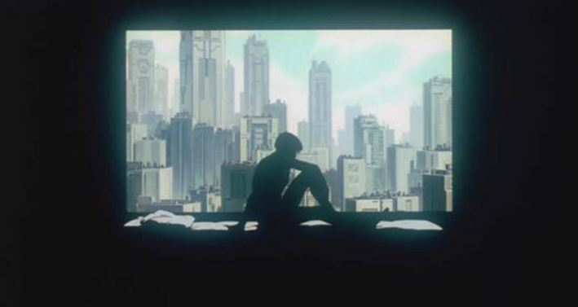

Fig. 1 Interior scene

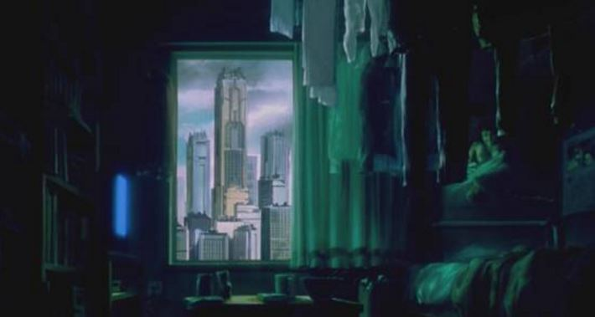

Fig. 2 Interior scene

The universal network, information intelligence and highly developed technology are materialized into mega metropolises which are mostly set as the background. In picture 1, the darkness has overcast the interior scene, and only the Silhouette of Motoko is shown in the picture as surrounded by the outdoor metropolis. The interior environment is stuffy and dark with a tone of cyan. In picture 2, high-rise buildings are standing outdoors in rain clouds, the narrow room, bed, cup and clothes, only the light emitted from the TV breaks the silence. The color is also in a depressed and gloomy cyan.

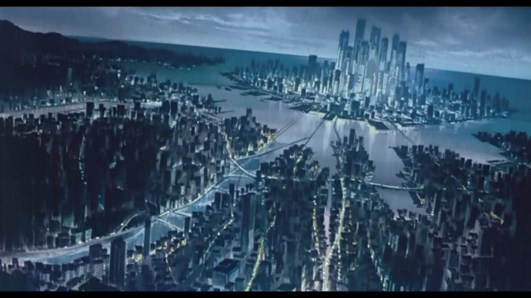

Fig. 3 An overall view of the metropolis

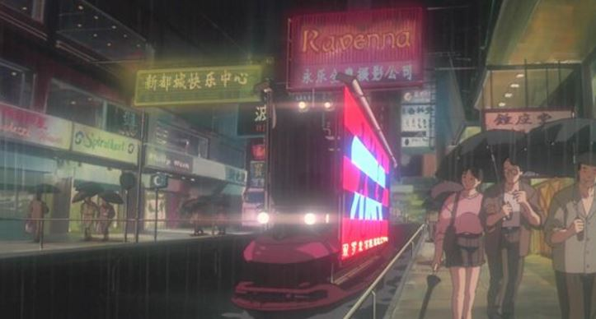

Fig. 4 Scene of Hong Kong

Picture 3 provides a bird’s eye view of the metropolis with the cold lights, and the whole picture is in the tone of cyan. Picture 4 presents the view of one street in Hong Kong, on the basis of the cool tone, the colorful neon lights are added to manifest the modernity. The entire tone in animation is in a harmonious cool tone.

B. <Ghost in the Shell，2017>

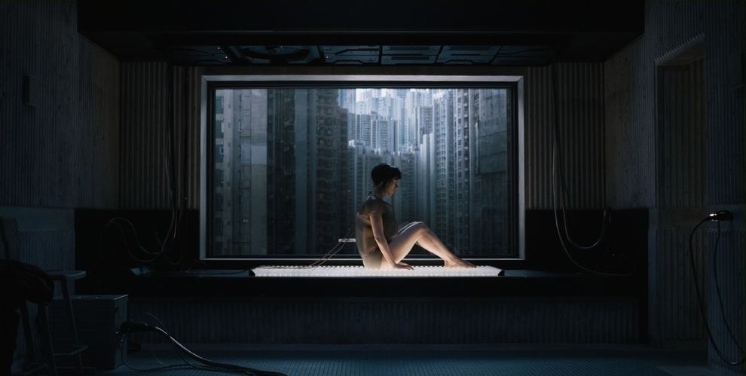

Fig.5 Interior scene

Picture 5 is originated from the film when Motoko wakes up, which is similar to the animation in background of metropolis. Compared to the stuffy interior environment, the lighting in film is more real and the light and shade contrast is softer. Without an obvious cool light resources, the film also creates a depressive atmosphere.
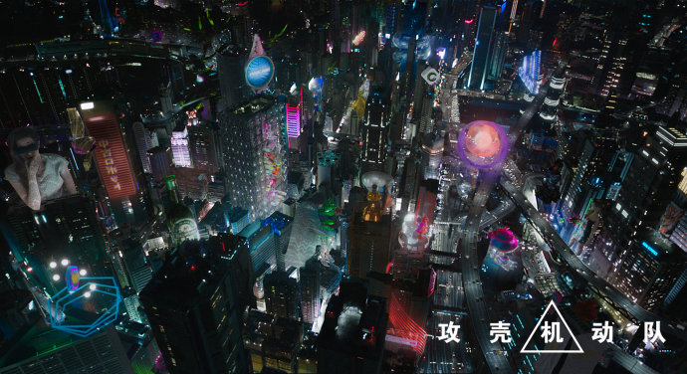

Fig. 6 An overall view of the metropolis

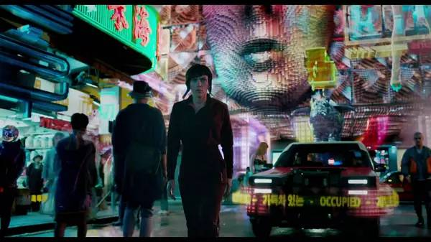

Fig. 7 Scene of Hong Kong

Based on an entirely cool tone, the film has expanded the areas of holographic projection and colored light resource like neon light, meanwhile, many brighter colors like pink and cyan blue are applied (these are popular colors in the recent design field) to replace the cyan tone in animation and hence promote the overall brightness in many scenes. By combing the plot, the film has adopted many Glitch Art elements to improve the fashion. Glitch refers to failure: a short-time impulse wave, which can also be understood as an automatic or artificial bug. Failures occur in the digital environment or generated by mechanical or man-made interference can therefore be classified as Glitch Art- a kind of failure-bade aesthetical creation, therefore, Glitch Art can also be regarded as the beautified glitch, or the creation method to complete aesthetical activities through glitch.

C. Comparison

 | Animation | film
Interior scene
Interior scene | Similarity: dark cool tone and stuffy interior environment;Difference: light and shade contrast is more intensive in animation, and its cool tone is more obvious.
Bird’s eye view
Bird’s eye view | Similarity: cool tone, mostly environmental light resource;  Difference: the animation has exaggerated the adoption of cyan which covers a large area; the color is diversified and colorful in film by using the artificial light resource like neon light.
Street
Street | Similarity: colorful, and the area of artificial light is large;  Difference: the film has expanded the areas of holographic projection and colored light resource like neon light by using Glitch Art element.

Small conclusion:for the animation of Ghost in the Shell is 2D hand-painted frame-by-frame film, the colors are designed by creators, then there is a great room for variation and imagination, which is closer to the painting features. While in live-action film, the tone of last pictures will be intensified, but it is still based on the exaggeration processing within the real scope and hasn’t deviated from the real life. Through a large area of neon light and holographic projection, the mainstream element like Glitch Art has made the film more fashionable, scientific and modern.

V. Conclusion

In both 1995 Ghost in Shell(animation) and 2017 Ghost in Shell(film), the cyberpunk style environment has been visually described, namely the highly urbanized and modernized environment and desolated slum. The thesis is aimed at analyzing the tone and light resource of cyberpunk scene to detect the similarities and differences between cyberpunk style animation and film. In animation, the color application is more exaggerated and bold, no matter in the urbanized environment or slum, the depressive and gloomy cool tone is prevailing. Most of the light resources are artificial (neon light). On the basis of cool-colored environment, the film has expanded the areas of holographic projection and colored light resource like neon light to strengthen the modern recognition of cyberpunk style high-tech sense; meanwhile, by applying Glitch Art element, the whole fashion has been promoted, which not only develops a new style in stereoscopic effect but also assists in the initial attempt of color. Besides, the Glitch Art element extremely conforms to the main topic of cyberpunk, both animation and film have visually performed the style of cyberpunk to the fullest. The film has enhance its modernity and high-tech sense.

References

[1] Dana J.Harraway,Min-gyeongsuk Station,[Anthropoid ape, cyberpunk,And she's a girl], Dongmun Line, 2002 Dana J.Harraway,Min-gyeongsuk Station, [Like a leaf], Galmurl,2005.
[2] Son Chang Hee, Dana J.Harraway’s Cyberspace study on Cyborg Attimation. Animation research. 2(1),53-69,2006.
- Carl Silvio, Refiguring the Radical Cyborg in Mamoru Oshii's "Ghost in the Shell", Science Fiction Studies, ( Mar, 1999 ), pp.55-72
- Balsamo, Anne. Technologies of the Gendered Body: Reading Cyborg Women. Durham, North Carolina: Duke UP, 1996.
- QianZhao，HeRong．Animated scene design and lens.(Second edition.)［M］．BeiJing:Renmin university of China press，2009．

